Conjured Identities Within Conjured Lines:

Magic as a Tool for Understanding in the Middle Ages

Jack Corp

Drury University

Phi Alpha Theta Biennial Conference

January 3, 2020

As the medieval world crept towards its autumnal age, the superstitions of the past remained vibrant and pervasive. In August 1438, Agnes Hancock stood before the Bishop of Bath and Wells “publicly defamed of the crime of magic.”[1] Hancock was not a harnesser of storms nor a conjurer of tricks, her magical prowess amounting to little more than simple medicinal concoctions for ailing children.[2] The enchanted qualities of these cures did not incite criminal accusation, but rather Hancock’s transgression of the known properties of the world, her encroachment on the boundaries of acceptable superstitious behavior. According to the court records, these magical cures, comprised of “unknown and strange words,” healed neither a cold nor a fever but the discomfort brought by interactions with the “spirits of the air” – beings impure and mischievous in which Hancock often sought counsel and aid.[3] This late medieval account of magical mischief operates within a universe teeming with angels and demons, sprites and fairies, forces beyond and within nature – all of which malleable to human desires. The concept of magic is continuously defined and redefined, its meaning imprecise and vague, necessitating an analysis of current scholarship to reveal anachronistic and aggregative shortcomings. Rather, medieval society drew upon a cumulative pool of definitions and boundaries to form a spectrum from which magic provided a shared approach to answer questions of identity and create a sense of order in a dynamic world.

Magic is a profoundly amorphous category of historical analysis. Its conceptual contours unstable throughout human society and across different ages, its scope and bounds not once limited to a set body of practices or singular definition.[4] The mercurial understandings of the term “magic” manifested in variable strands, forming parallel histories and definitions as philosophical and scientific writings engaged with its underlying concepts.[5] Moreover, these concepts are themselves troublesome to categorize, often mutated by social and historical context, its divisions shadowing and blurring as much as it reveals.[6] Low and high, black and white, and even ritual and natural magic are incomplete divisions. Scholarship on magic generally rests on anachronistic understandings constructed from the Latin *magia, magica,* or *ars magica* – generic, abstract terms limited in descriptive power, exclusive to educated language, and not frequently used in manuscripts.[7] Medieval authorities referred broadly to particular “magical arts,” such as necromancy or divination.[8] This, too, is problematic and undermines scholarship’s understanding of the term “magic.” Makers of potions and alchemical convocations did not describe their formulas asmagic, nor did the astrologers on the movement of the stars.[9] With this in mind, natural, ritual, and angel magic, the cases of magical arts to be discussed, cannot be considered distinguishable forms of an absolute, clearly definable entity, but mutually supportive concepts that create a spectrum of constitutive elements. Thus, use of the term “magic,” built upon an aggregation too ambiguous and resistant to precise usage, is ill-equipped to describe the complexities of medieval magical thought.

This is not an attempt to redefine magic, for its aggregative nature does contain actual knowledge, its divisions convenient for general discussion and popular discourse. Rather, it is an attempt to apply a method of understanding that calls upon the historian to rethink *how* to define magic.[10] By focusing on the constitutive – the spectrum – rather than the whole, magic becomes a more precise and relatively less ambiguous subject of analysis; its language less connotative.[11] Richard Kieckhefer, whose research aided in defining magic in traditional history, proposed three constitutive terms in the 2019 essay “Rethinking How to Define Magic.” In this piece, the first term, conjuration, concerns the summoning and commanding of spirits, good, evil, or otherwise, through ritual action. Spirits, therefore, must be considered rational actors in the medieval universe, possessing a definitive presence and a will vulnerable to subjugation.[12] Next, symbolic manipulation recognizes the natural world as containing symbolic links to occult properties. Thus the medieval universe is one rife with potential power, each rock, plant, and object a pathway to express a sense of control or understanding over one’s surroundings. Finally, directly efficacious volition is the extension of the will into reality. However, it is only magical if the practitioner believes its effects to be a direct product of psychological energy, typically expressed through language, such as a curse.[13] Like magic itself, these terms must not be considered separate elements. Indeed, the very nature of magic as a spectrum necessitates otherwise, for the *Æcerbot*, Middleham Jewel, and the *Ars notoria*, the three exceptional artifacts to be examined in this paper, are not monolithic units but a distinct blend of each constitutive concept.

From its roots in antiquity and the early Christian tradition, “magic” has always been an imprecise assemblage of variable practices. Its cumulative quality and conceptual basis in medieval culture crawled out of an age in which the supernatural was near indistinguishable from the divine.[14] Keen to carve a line between godly manifestations and diabolical power, early Christian theologians rationalized the word of God within the context of pre-existent traditions -- some of which threatened not only the souls of the faithful but the entire Christian order.[15] As the inheritor of the post-Roman world, medieval society emerged out of a struggle between the traditions of Germanic paganism and Christian theology: each a contributor to an amalgamation of religious beliefs. This interplay developed the grounds from which early Christian thinkers, such as Augustine of Hippo, could further articulate the definitive division between church rituals and illicit behavior, thereby creating the initial “lineaments of an idea transferable across various discursive field and boundaries.”[16] To support the view of magic as a cumulative pool of definitions, the art of divination, which features each constitutive elements in full, will be tracked across the work of foundational early and high medieval authorities.

Completed in 426, Augustine’s *On Christian Thinking* defines magic as it relates to Christian behavior, establishing a framework in which “all subsequent medieval authorities operated.”[17] To be Christian, argues Augustine, is to abandon all superstition, to leave notions of truth to the providence God, not the deadly pagan practices of magic.[18] Augustine links the desired effects of magic as being a product of demons designed to “establish certain secret…meanings.”[19] It is the art of astrology, however, that best represents the dynamic process by which understandings of magic morphed in early Christendom. A form of divination, astrology is a cross-section of astral and natural magic, demanding of the practitioner extensive knowledge of natal charts and of the occult properties of celestial objects. Augustine writes that astrologers are no better than slaves to false gods, and, worse still, perpetrators of “spiritual fortification.”[20] Such a strong condemnation worked to create a clear separation between magic and proper Christian devotion, a tactic which, in a time that blurred the lines of magic and religion, provided spiritual stability. In addition, Augustine noted the study of natal charts for medicinal or prophetic purposes instilled a sense of agency into the individual; however, such an “alliance of men and devils…whose whole aim, in concert with their leader, the devil, is to cut off and obstruct [humankind’s] return to God” and instill a “dangerous curiosity” that transgress divine providence.[21] Yet, the biblical story of the Magi, in which the Three Wise Men saw the Star of Bethlehem as the coming of the Messiah, is wholly incompatible with Augustine’s condemnation of astral magic. It is not until the early seventh-century, under the writings of Isidore of Seville, that astrology is fully redefined to better match the Christian tradition.

Isidore’s *Etymologies,* a seventh-century encyclopedia of early Christian and classical knowledge, is not simply a continuation of the Christian meaning of magic started by Augustine, but an attempt to rationalize illicit practices in the stories of the faith. Chapter nine of the *Etymologies*, titled “On the Magi,” follows Augustine, presenting magic as a “pestilential association” of humans and demons formed to corrupt divine miracles.[22] The title’s use of the Latin *magi* is ambiguous, the term unable to define a specific kind of magician. Once a descriptor of the Zoroastrian priests, *magi* transformed into a blanket encompassing all sorts of occult practionner.[23] Within the text itself, however, the concept of magic is of greater clarity as Isidore distinguishes between magicians -- practionners of the occult -- and diviners, the suppliers of occult knowledge.[24] Within the acts of the magicians, argues the text, “there is no miracle,” pointing to the Pharaoh’s magicians, Jannes and Jambres, “whose arts reached such perfection that they actually resisted Moses by wonders very like his.”[25] On diviners, the boundaries of magic shift to not only condemn the art of astral magic, but make sense of its connection to the Three Wise Men.[26] Isidore asserted that God granted knowledge of astrology, a form of divination, up until the time of Christ’s birth, after which the reading of “the nativity of anyone from heaven” was forbidden.[27] However, the *Etymologies’* classifications are not absolute, with certain arts, such as necromancy, shifting across the boundaries of the magician and the diviner.[28] Practionners of hydromancy, moreover, cannot be neatly tucked into a single category, as they use the art to “summon the shades of demons…to be told some things by them,” conjuring the dead while also seeking occult knowledge.[29] Isidore’s *Etymologies* reveals a process of rationalization that sought to bring magical practices within the confines of Christian belief. By redefining and redistricting proper engagement with the supernatural, Isidore resolves an issue of religious identity set by Augustine, continuing the cumulative evolution of magic which lingered late through the Middle Ages as theologians distanced the saint from the magician.

The commitment to discerning between a magician and a saint further illustrates Christianity’s desire to construct a firm identity free from illicit magic. As self-proclaimed practitioners of supernatural power, the existence of magicians undermined the role of saints as divinely-ordained agents of the Christian faith. With medieval society teeming with pathways to achieve magical power, be it through knowledge of herbs or simple charms, the individual possessed an extraordinary power, imaginary or not, to force the world into a coherent order. To the ecclesiastical hierarchy, this posed a threat to the Church’s hegemonic control over the spiritual world, resulting in a paradigm shift that placed the actions of magicians at odds with works of saints.[30] Take, for example, the eleventh- to twelfth-century illuminated manuscript illustration of the magicians Jannes and Jambres: a pair of Egyptian brothers who used supernatural powers against Moses and Aaron.[31] In this Anglo-Saxon illustration, Jannes, holding a book of necromantic incantations, stands before an opening of hell, attempting to pull Jambre’s soul from the inferno. The position of this magician, who dared oppose Moses and Aaron, is vulnerable as the demons below reach from the depths. Serpents, devils, and great beasts torture the bodies of those condemned, bodies contorted and bloodied. More important than the threat of damnation is the connection drawn between the practice of magic and its ability to attract demons. Through the art of necromancy, Jannes can create a direct pathway to Hell. This visual representation of the dangers of magic – and the folly of magicians – does not deny the existence of supernatural forces beyond God but contextualizes these opposing forces within a framework of Christian theology, warning of its dangers and abandonment of the faith.

This illuminated manuscript of Janne’s invocation reflects an understanding of magic proposed by Augustine and Isidore; however, in the thirteenth-century a new approach formulated under the works of Thomas Aquinas. As an inheritor of the traditions set by Augustine and Isidore, Aquinas represents the cumulation of magical understandings through the High Middle Ages. Under the writings of Aquinas, such as the 1265-1274 *Summa Theologica,* the old dichotomy of paganism versus Christianity fell abandoned to the scholastic divide between divine power and demonic activity within the natural world.[32] Like his forebearers, divination was a point of scrutiny. The Aquinas’ treatise *Summa contra Gentiles*, written between 1259 and 1265, expressed that many seemingly natural rites and practices, such as astrology, were in reality products of demonic power.[33] The usage of spoken incarnations and inscribed characters, Aquinas argues, holds no legitimate power over celestial objects and is an attempt to achieve results far beyond the natural order.[34] Therefore, the magician’s invocations were directed not to the stars but demonic beings.[35] Whereas the language of Augustine proposed the channeling of demonic power, Aquinas developed the concept of magic as a demonic pact, the use of incantations and rites a direct conjuration of fiends and devils. For late medieval authorities, Aquinas’ approach to magic became an imperative resource to separate permissible rights from superstition.[36]

The writings of Augustine, Isidore, and Thomas Aquinas are testaments to the dynamic intellectual exchange of the Middle Ages. The conceptual understandings of magic, formally contextualized into Christian theology by Augustine, found further development under Isidore, whose *Etymologies* resolved the gaps in Christian identity created by the former’s strict condemnation. Aquinas furthered this amorphous evolution of magic, once more redefining its conceptual boundaries to include contemporary issues of demonology, linking the practionner to a diabolical pact. However these writings engage with magic exclusively at the theoretical level, each a product of an ecclesiastical agenda. To focus on theology obscures the common usages of the condemned concepts labeled “magic,” and thus a shift from theory to practice is necessary to fully explore magic in medieval society.

At the foundation of common and natural magic is the idea that all objects possess qualities of the occult. Many required rituals or blessings to active these powers, though others, by virtue of peculiar properties, emit a natural force.[37] These objects were expected byproducts of the medieval universe, their properties a rationalization of anomalies and marvels in a world of divine manifestations. This is not to say, however, that the category of natural magic is a distinct division of magic. Rather, as illustrated by the *Æcerbot* charm, common practices can defy the divisions carved by historians. Recorded in late tenth- to early eleventh-century, the *Æcerbot*, or “Field Remedy,”is a Saxon ceremony, ritual, and charm designed to heal land damaged by sorcerers or poisoners.[38] It is an expression of symbolic manipulation and direct volition designed to make sense of a poor harvest or an unyielding field. The ritual calls for “oil and honey and yeast, and milk of each animal that is on the land, and piece of each type of tree that grows on the land…and a piece of each herb known by name, except burdock” to be gathered and dripped three times in holy water.[39] The practitioner must also recite a short charm: “Crescite, grow, et multiplicamini, and multiply…” – all within “the name of the father and the son and the holy spirit.”[40] What follows is a complicated ceremony of repetitious rituals and charms, each engaging with the occult qualities of the natural world and the divine power of God. Further complications arise when the source is taken into consideration. The *Æcerbot* is not known to history as a survivor of an oral tradition, but as a product recorded by a member of the clergy in late Saxon England. The invocations of Mother Earth and Father God demonstrate two spiritual agencies that conjure separate understandings of magic; a hybridization of categories – popular and formal religion, common and learned magic – merge to form a spectrum of belief from which medieval individuals can harness shared approaches of understanding.[41]

Along this spectrum of magic are pendants and amulets – jewelry of supernatural ability that resist, like the *Æcerbot* charm, compartmentalization as they often employ numerous magical arts to provide a sense of agency and order in the wearer’s life. Crafted around 1460, the Middleham Jewel is a sapphire and gold pendant with scenes of the Trinity and Nativity carved onto its frame.[42] The borders are lined with Latin script: “Behold the Lamb of God, who takes away the sins of the world,” supplementing the Christian iconography biblical verse. Intermixed with the appeals to the Christian faith are the words *tetragrammaton* and *ananizapta* – terms often recited in incantations and charms to ward off the effects of epilepsy.[43] A combination of healing magic and Christian prayer, the Middleham Jewel also features sapphire, a stone with occult properties rooted in medicinal and protective powers.[44] Like the *Æcerbot*, the Middleham Jewel contains symbolic manipulation through its use of the sapphire, in addition to direct volition through charms both licit and illicit. The pendant is unique, however, in its craftsmanship which could only belong to an elite of medieval society, illustrating that the conflation of religious and magical beliefs, of natural, ritual, and charm magic, was not solely performed by the common people, but instead, a practice shared across each level of society.

Works such as the *Ars notoria*, however, were indeed exclusive to the learned class, its contents purposefully only for those engaged in scholasticism. First appearing in the late twelfth to the early thirteenth-century, the *Ars notoria* is manuscript comprised of a program of prayers, rituals, meditations, and figures to aid in the acquisition of knowledge.[45] Evidently, the *Ars notoria* features similar elements to both the *Æcerbot* and the Middleham Jewel, namely the conflation of ritual magic and Christian prayers. However, this manuscript also includes heavy usage of astrology, calling upon the practitioner to observe astrological restrictions to obtain certain knowledge, as well as the conjuration of angels.[46] As a fusion of spiritual and educational goals, the *Ars notoria* survived the age without overt allegations of demonic interaction, medieval authorities, and those who used it, preferring to focus on its ability to acquire such knowledge through the traditional Christian practices of prayers and fasts.[47] Nevertheless, its extensive use of diagrams, incantations, and even concoctions attests to the usage of occult beliefs to manipulate the supernatural forces of the universe to the will of the practitioner.

From the temporal to the spiritual realms, the Middle Ages teemed with magic. Such a term, however, limited its precision as a historical point of analysis, must recognize its fallibility as a traditionally absolute concept. While splitting magic into subcategories like natural properties, ritual incantations, or angelic invocation is suitable for general discourse, such divisions obscuring upon further analysis. In fact, the very boundaries of magic are amorphous, its scope extending and contracting as intellectual authorities theorize its relation to religion and reason. However, engagement with the concept of magic is not exclusive to the learned elites – far from it, in fact, as evidenced by the *Æcerbot* which conflates popular and formal belief in a text of not one, but rather numerous magical arts.As such, medieval magic refers to a spectrum of conjuration, symbolic manipulation, and directly efficacious volition – each a mutually supportive element capable of withstanding the ebbs and flows of a cumulative concept. Within medieval society, magic operated within a unique space of acceptance and rejection, for it served as both a tool for understanding and a weapon of doubt. Christian theologians, concerned with control over spiritual functions, saw the magical traditions of the Antiquity as a threat to order, forcing several processes of rationalization and absorption as supernatural practices encountered Christianity. The temporal world, while not wholly separated from the spiritual, accepted elements of the supernatural to make sense of an uncertain universe. Threats of physical misfortune, risks of famine, and, for those fortunate, the stress of university dominated the minds of the individual. Through magic, however, these otherwise turbulent issues fell into a coherent reality governed by a set of shared practices and arts. As the paradigms of the Middle Ages evolved throughout the ages, so too did the concept of magic and its relation to the magician. For as the early modern period grew near, Augustine’s warnings of diabolism met full realization as the magician, a harnesser of arts and occult knowledge, morphed into the lover of Satan, the devourer of infants: the witch.

Appendices

Appendix A: Illuminated Manuscript Illustration of Jannes Performing Necromancy

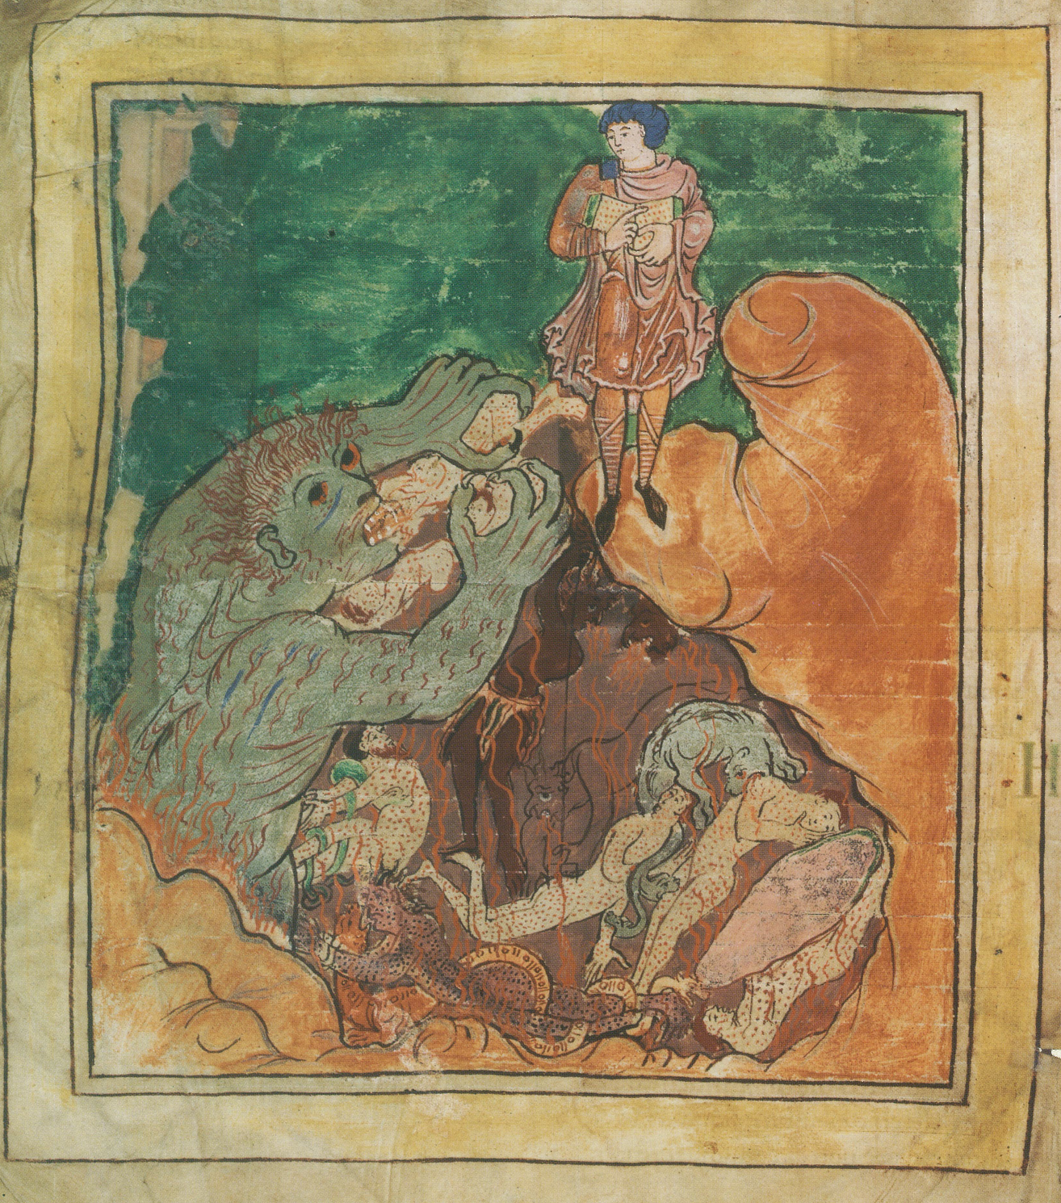

Source: Jannes and Jambres, London, British Library, Cotton MS Tiberius B V/1, fols, 87r-87v. http://www.bl.uk/manuscripts/Viewer.aspx?ref=cotton_ms_tiberius_b_v!1_f002r

Appendix B: Middleham Jewel

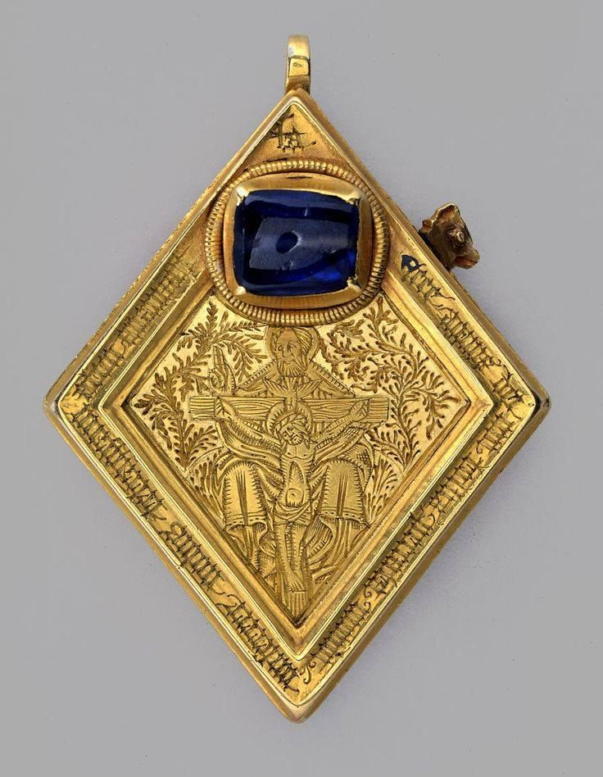

Source: *Middleham Jewel*. Photograph. York: York Museum. https://www.yorkmuseumstrust.org.uk/collections/search/item/?id=540&search_query=bGltaXQ9MTY=.

Bibliography

Primary Sources:

Augustine. “On Christian Thinking, 426.” In *Witchcraft in Europe 400-1700: A Documentary History*, ed. Alan Charles Kors and Edward Peters, 43-47. Philadelphia: University of Philadelphia Press, 2001.

Aquinas, Thomas. “Summa contra gentiles, 1259-1265.” In *Witchcraft in Europe 400-1700: A Documentary History*, ed. Alan Charles Kors and Edward Peters, 90-96. Philadelphia: University of Philadelphia Press, 2001.

Isidore of Seville. “Etymologies, 615-630.” In *Witchcraft in Europe 400-1700: A Documentary History*, ed. Alan Charles Kors and Edward Peters, 50-54. Philadelphia: University of Philadelphia Press, 2001.

*Middleham Jewel*. Photograph. York: York Museum. https://www.yorkmuseumstrust.org.uk/collections/search/item/?id=540&search_query=bGltaXQ9MTY=.

London, British Library, Cotton MS Caligula A VII, fols, 176r-178r. http://www.bl.uk/manuscripts/Viewer.aspx?ref=cotton_ms_caligula_a_vii_f011r.

London, British Library, Cotton MS Tiberius B V/1, fols, 87r-87v. http://www.bl.uk/manuscripts/Viewer.aspx?ref=cotton_ms_tiberius_b_v!1_f002r

Secondary Sources:

Bailey, Michael D. "A Late-Medieval Crisis of Superstition?" *Speculum* 84, no. 3 (2009): 633-61.

Bailey, Michael David. *Fearful Spirits, Reasoned Follies : The Boundaries of Superstition in Late Medieval Europe*. Ithaca: Cornell University Press, 2013.

Bailey, Michael. *Magic and Superstition in Europe: a Concise History from Antiquity to the Present*. Lanham, MD: Rowman & Littlefield Publishers, 2007.

Hutton, Ronald. "How Pagan Were Medieval English Peasants?" *Folklore* 122, no. 3 (2011): 235-49.

Jolly, Karen Louise. *Popular Religion in Late Saxon England: Elf Charms in Context*. Chapel Hill: University of North Carolina Press, 1996.

Kieckhefer, Richard. “Rethinking How to Define Magic.” In *The Routledge History of Medieval Magic*, edited by Sophie Page and Catherine Rider, 1st ed. New York, NY: Routledge, 2019.

Kieckhefer, Richard. "The Specific Rationality of Medieval Magic." *The American Historical Review* 99, no. 3 (1994): 813-36.

Klingshirn, William E. “Isidore of Seville's Taxonomy of Magicians and Diviners.” *Traditio* 58 (2003): 59–90.

Kors, Alan, and Edward Peters. *Witchcraft in Europe: 1100-1700: A Documentary History*. Philadelphia: University of Pennsylvania Press, 2001.

Page, Sophie. *Magic in Medieval Manuscriptshttp://www.assoc-amazon.com/e/ir?t=esotearchi-20&l=as2&o=1&a=0802037976*. Toronto: University of Toronto Press, 2004.

Rider, Catherine. *Magic and Religion in Medieval England*. London: Reaktion Books, 2012.

Watkins, Carl. "‘Folklore’ and ‘Popular Religion’ in Britain during the Middle Ages." *Folklore* 115, no. 2 (2004): 140-50.

1. Catherine Rider, *Magic and Religion in Medieval England* (London: Reaktion Books, 2012), 70.
2. Ibid., 70.
3. Ibid., 59.
4. Richard Kieckhefer, “Rethinking How to Define Magic,” in *The Routledge History of Medieval Magic*, ed. Sophie Page and Catherine Rider (New York: Routledge, 2019)), para. 1.
5. Richard Kieckhefer, “The Specific Rationality of Medieval Magic,” *American Historical Review* 99, no. 3 (1994): 815-817.
6. Michael Bailey, *Fearful Spirits, Reasoned Follies: The Boundaries of Superstition in Late Medieval Europe* (Ithaca: Cornell University Press, 2013), 26.
7. Kieckhefer, “Rationality,” 815.
8. Bailey, *Fearful Spirits,* 26
9. Kieckhefer, “Rationality,” 815.
10. Kieckhefer, “Rethinking Magic,” para. 4.
11. Ibid.
12. Ibid., para. 7.
13. Ibid., para. 9. No external mechanisms can mediate acts of volition, for if it is to be considered magical, its effects must be seen as, in the case of curses, an expression of malevolent will. Language, for example, is a tool to extend psychological energy into explicit reality, carrying power that directly harms the victim. While conjuration may seem an extension of the will, inherent to its meaning is the engagement with a conjured spirit.
14. Bailey, *Fearful Spirits,* 19.
15. Carl Watkins, ""Folklore" and "Popular Religion" in Britain during the Middle Ages." *Folklore* 115, no. 2 (2004): 140-50.
16. Claire Fanger, “For Magic,” in *The Routledge History of Medieval Magic*, ed. Sophie Page and Catherine Rider, 1st ed. (New York: Routledge, 2019), para. 8.
17. Bailey, *Fearful Spirits,* 40.
18. Augustine, “On Christian Thinking, 426,” in *Witchcraft in Europe 400-1700: A Documentary History*, eds. Alan Charles Kors and Edward Peters (Philadelphia: University of Philadelphia Press, 2001), Chapter I, 44.
19. Augustine, “On Christian Thinking,” 45.
20. Ibid., 45.
21. Ibid., 46.
22. William E Klingshirn, “Isidore of Seville's Taxonomy of Magicians and Diviners,” *Traditio* 58 (2003), 70.
23. Klingshirn, “Isidore of Seville’s Taxonomy,” 63.
24. Ibid., 63.
25. Isidore, “Etymologies, Book VIII, Chapter 9,” in *Witchcraft in Europe 400-1700: A Documentary History*, eds. Alan Charles Kors and Edward Peters (Philadelphia: University of Philadelphia Press, 2001), Chapter I, 51.
26. Michael Bailey, *Magic and Superstition in Europe: A Concise History from Antiquity to the Present* (Lanham, MD: Rowman & Littlefield Publishers, 2007), 58.
27. Isidore, “Etymologies, Book VIII, Chapter 9,” 53.
28. Klingshirn, “Isidore of Seville’s Taxonomy,” 63.
29. Isidore, “Etymologies, Book VIII, Chapter 9,” 52.
30. Sophie Page, *Magic in Medieval Manuscripts* (Toronto: University of Toronto Press, 2004), 8. See Appendix A.
31. Jannes and Jambres, London, British Library, Cotton MS Tiberius B V/1, fols, 87r-87v.
32. Bailey, *Fearful Spirits*, 70.
33. Ibid., 68.
34. Thomas Aquinas, “From the *Summa contra gentiles*: Sorcery and the World of Nature,” in *Witchcraft in Europe 400-1700: A Documentary History*, eds. Alan Charles Kors and Edward Peters (Philadelphia: University of Philadelphia Press, 2001), Chapter III, 91.
35. Aquinas, “Summa contra gentiles,” 96.
36. Bailey, *Fearful Spirits*, 69.
37. Page, *Magic*, 21.
38. Karen Louise, Jolly, *Popular Religion in Late Saxon England: Elf Charms in Context* (Chapel Hill, NC: University of North Carolina Press, 1996), 6-8.
39. Jolly, *Elf Charms*, 6.
40. Ibid., 6.
41. Ibid., 11.
42. *Middleham Jewel*, photograph, *Middleham Jewel* (York: York Museum Trust, n.d.), York Museum, https://www.yorkmuseumstrust.org.uk/collections/search/item/?id=540&search_query=bGltaXQ9MTY=),

    See Appendix B.
43. Rider, *Medieval England*, 104.
44. Ibid., 105.
45. Frank Klaassen, *The Transformations of Magic: Illicit Learned Magic in the Later Middle Ages and Renaissance* (Penn State University Press, 2013), 89.
46. Klaassen, *Transformations of Magic*, 90.
47. Ibid., 92.